Note: This tutorial is for Github Enterprise with personal account NOT Enterprise with Managed user (EMU)

Step 1 — Go to Enterprise Settings
- Open your web browser and navigate to:
https://github.com/settings/enterprises
- Make sure you are signed in with your GitHub account

https://github.com/settings/enterprises
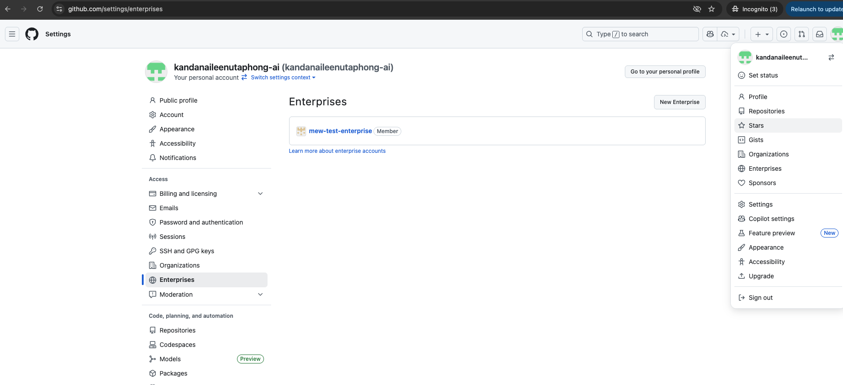
Click New Enterprise on the right side of the page.

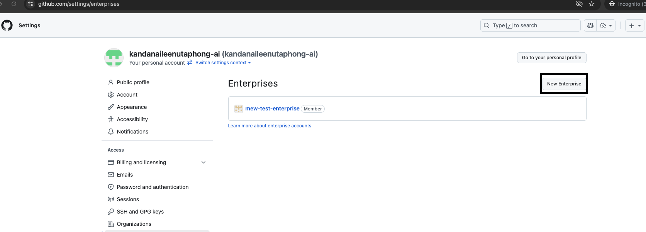

There are two options. In this tutorial we will prioritize the first option. (if you don't have an existing IDP (E.g. Microsoft Entra ID). )
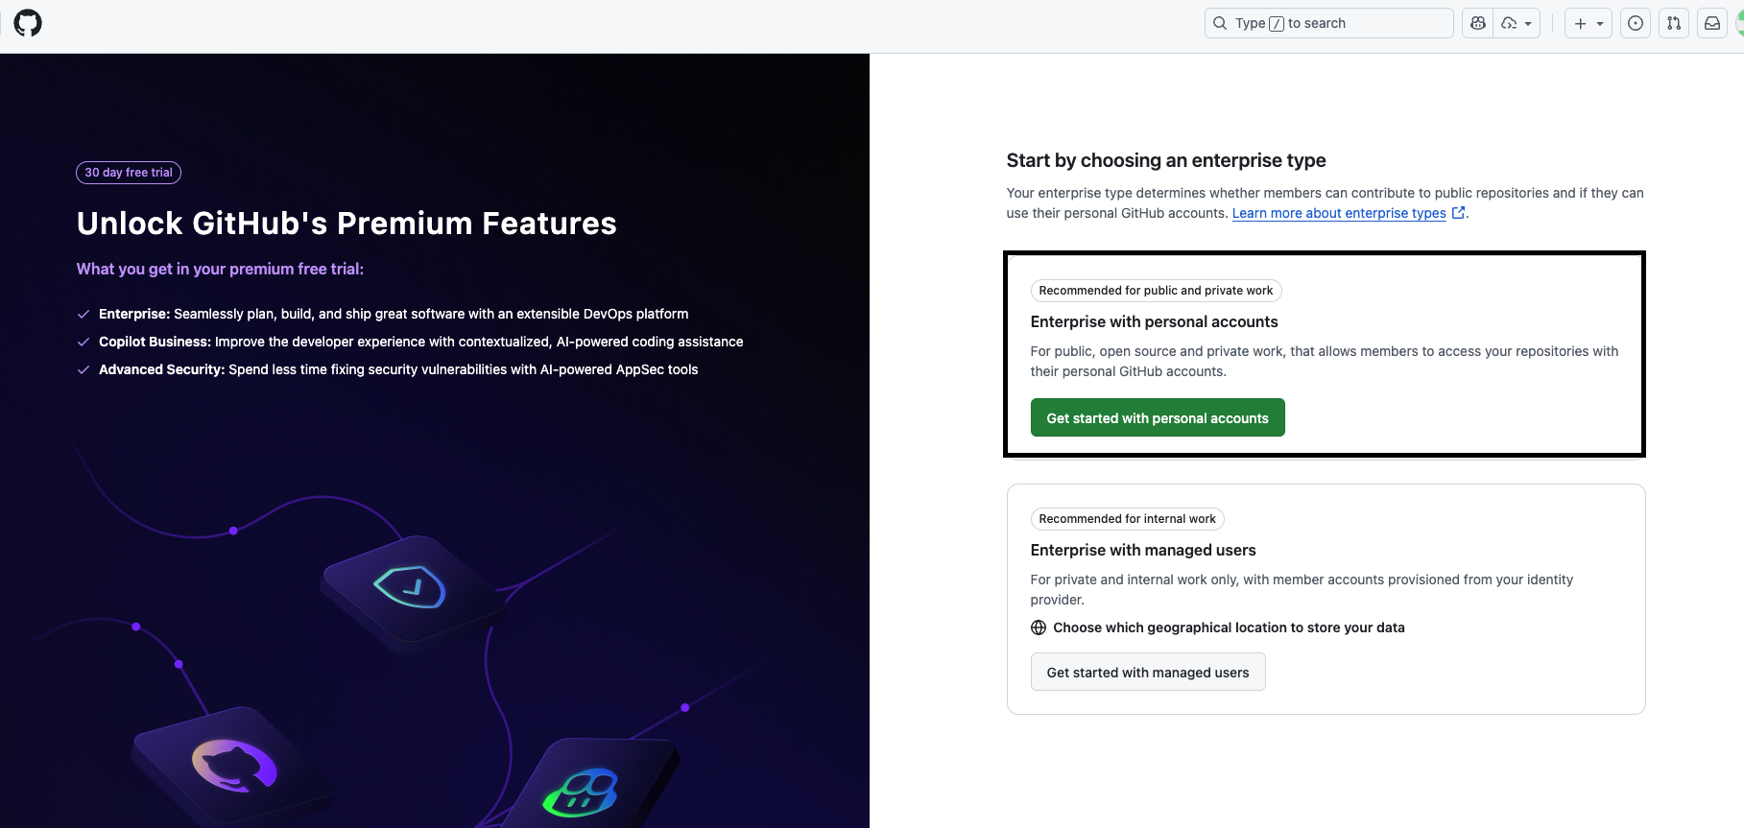

Continue filling the form.
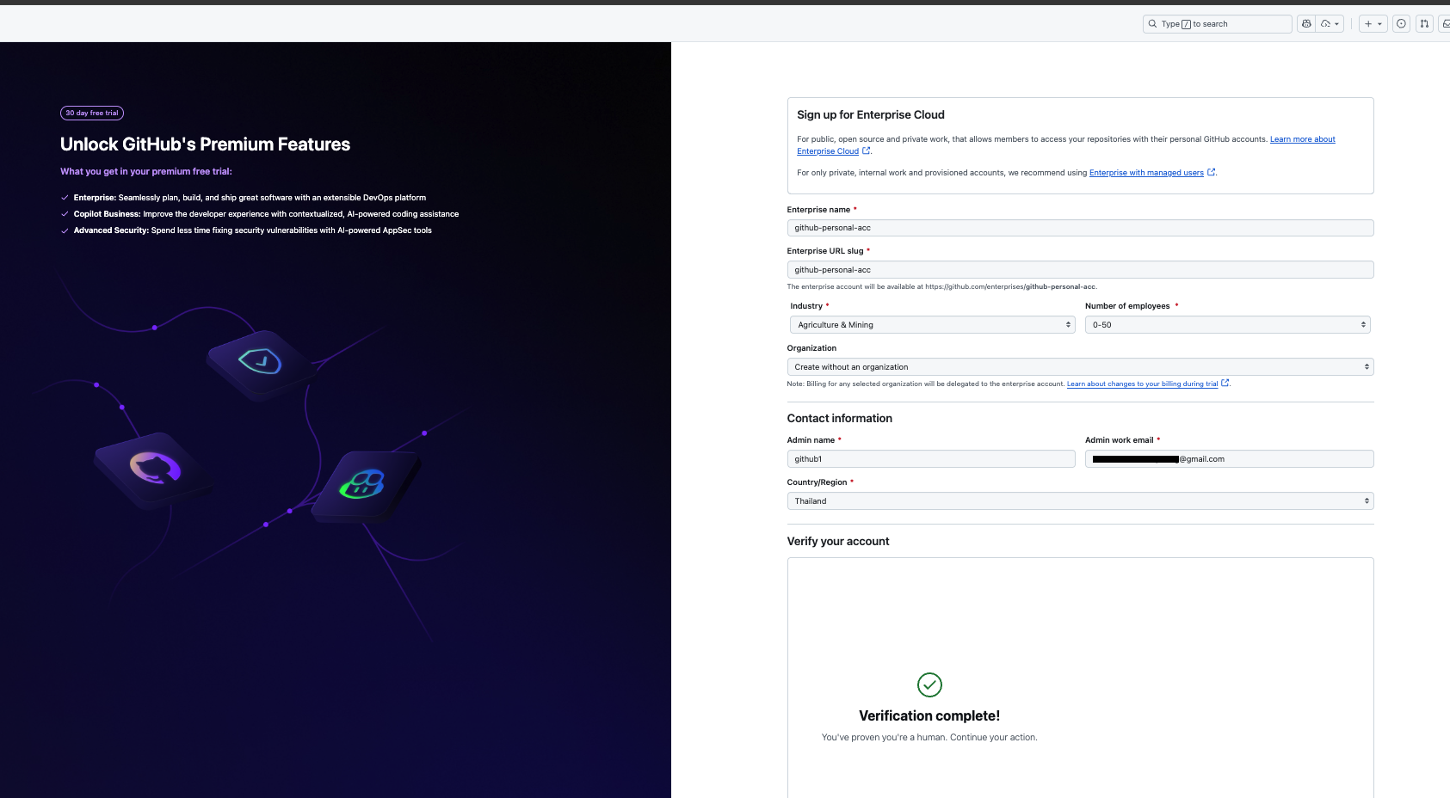

Importantly here, select the payment method -> Add Azure subscription
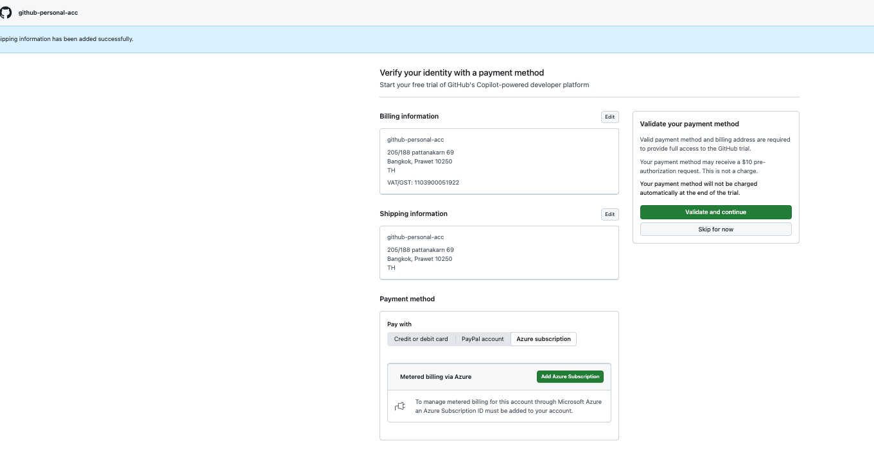

Sign in with your azure account with azure subscription & github enterprise with your azure subscription
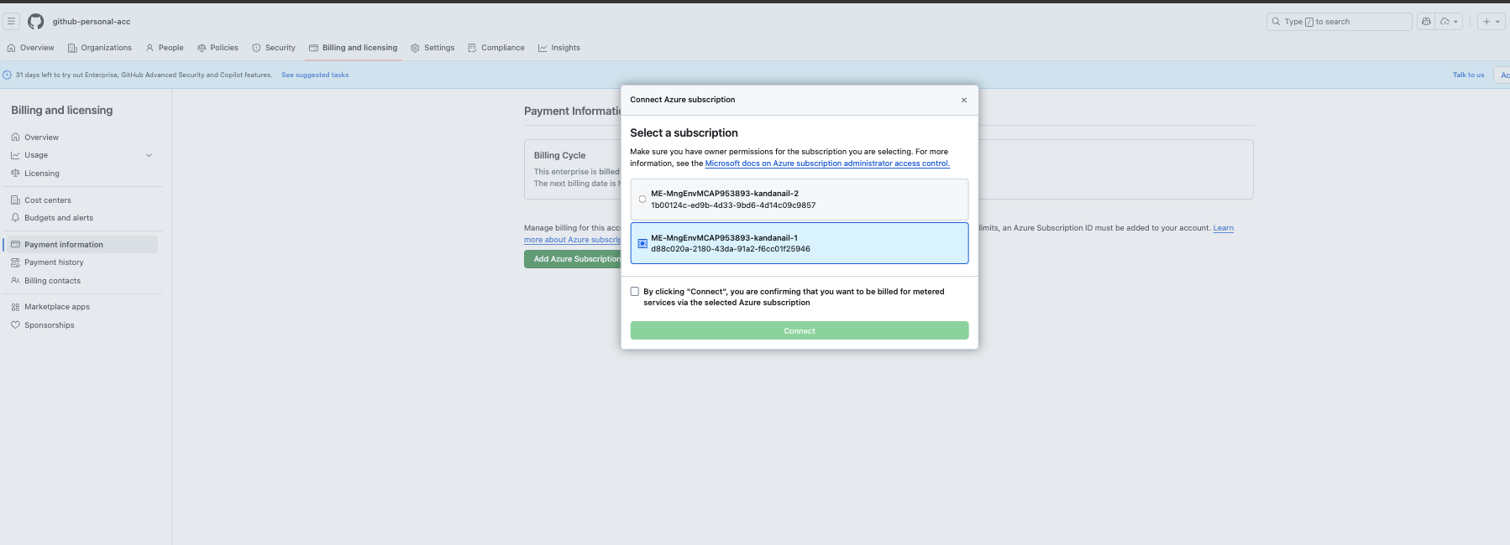

Continue filling the forms.
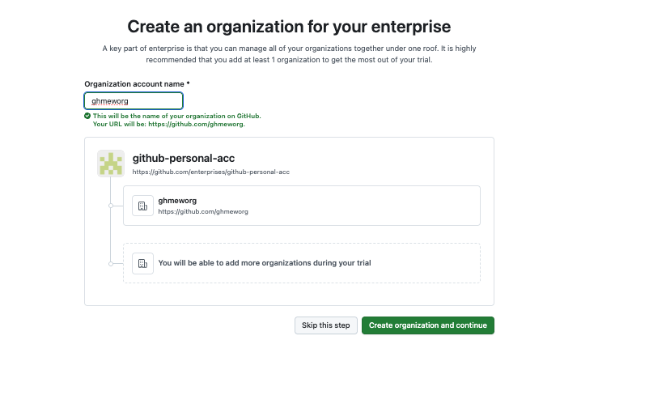

Ensure you activate the enterprise license
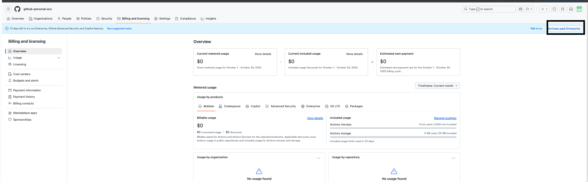
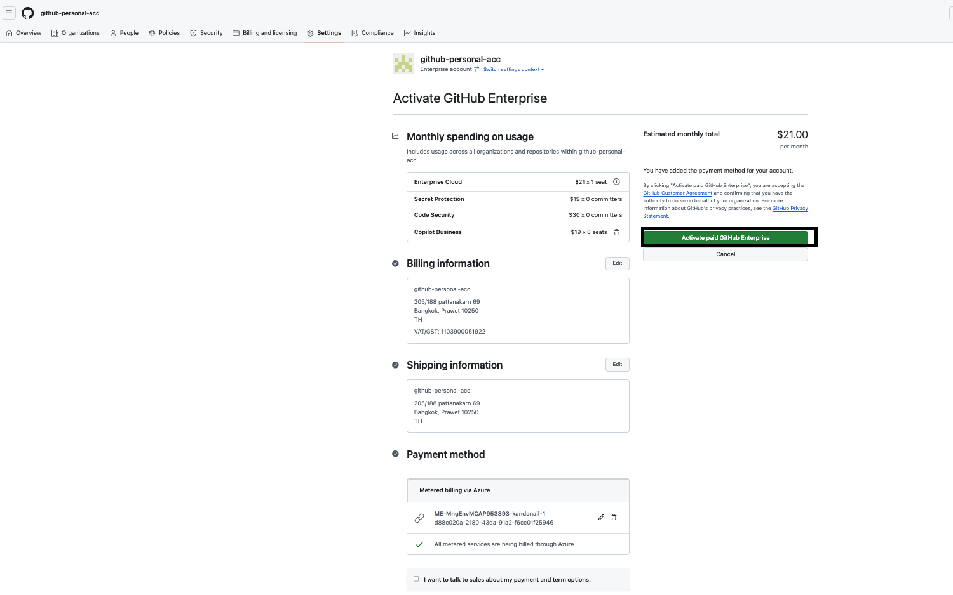
You are done, you can view the license page to see the number of consumed license.

https://github.com/enterprises/{org_name}/enterprise_licensing
